**FireGuard Drones**

Houston Community College

Unmanned Aerial Systems (UAS) Traffic Management

TOP2-237  
Safe2Ditch Technology

LAR-TOPS-243  
  
Jonah Phillips (Team Lead)

[W215692135@student.hccs.edu](mailto:W215692135@student.hccs.edu)

Houston Community College

Marco O’Malley

[W214683231@student.hccs.edu](mailto:W214683231@student.hccs.edu)

Houston Community College

Phu Thanh Pham

[W212478236@student.hccs.edu](mailto:W212478236@student.hccs.edu)

Houston Community College

Beatrice Olaosebikan

[W213378005@student.hccs.edu](mailto:W213378005@student.hccs.edu)

Houston Community College

Princess Shedrack

[W215198902@student.hccs.edu](mailto:W215198902@student.hccs.edu)

Houston Community College

Vedron Bordeaux (PI)

[vedron.bordeaux@hccs.edu](mailto:vedron.bordeaux@hccs.edu)

713-718-5298

Houston Community College

**Innovation**

By incorporating NASA’s Unmanned Aerial System (UAS) Traffic Management (UTM) IP, we envision safe and efficient airspace operation of our revolutionary aerial firefighting UAS technology, enabling autonomous fire suppression capabilities for firefighters in the day and at night (i.e., night shift). Our UAS technology consists of an autonomous swarm of large firefighting UAS systems, proprietary mission planning software (computer applications), and NASA’s UTM and Safe2Ditch IPs. Together, these systems make a revolutionary new tool for wildland firefighting. NASA’s UTM IP would enable seamless integration of large UAS swarms in the incident airspace in support of a wildfire emergency. Allowing an autonomous large UAS to navigate through the complex environments of the incident airspace. NASA’s Safe2Ditch IP gives the UAS options for minimizing the harm it may possess in a congested airspace environment, like in a wildfire. We envision safety features like “see and avoid," where the large UAS would use its onboard ASAP-U module to identify incoming manned aircraft and perform evasive maneuvers like a quick change in altitude and lateral travel. Additionally, the large UAS’s water tank could explode, releasing its payload of fire agents in midair during a free fall due to a critical system failure, i.e., loss of power.``

There are a few regulatory hurdles in the way of our swarm of large UAS technology. We would have to comply with the rules and safety standards that are put in place by the Federal Aviation Administration (FAA). In order to get approval for our technology, we would need to apply for a Certificate of Waiver or Authorization (COA). The FAA has a Special Governmental Interest policy or SGI, which expedites and speeds the waiver application process for first responders and other organizations responding to natural disasters. NASA’s UTM IP will help further streamline the waiver application because it is a FAA verified technology that allows easy integration of UAS into the National Air Space (NAS). Additionally, with NASA’s Safe2Ditch IP, we can demonstrate the safety of our large UAS system which is greater than 55 lbs and as such, may pose risks.   
  
 Our large UAS unit is a gas-powered heavy-lift coaxial rotorcraft capable of carrying up to 1,500 lbs (which includes its body weight and a full tank of water, i.e., 100 gallons) by using a 560 HP turboshaft engine, similar to most type 3 helicopters used in wildfire operations. Additionally, our coaxial rotorcraft eliminates the need for a tail rotor, like on most modern aircraft.

As our UASs operate in the fleet, they can autonomously work together to create a firebreak that aids firefighters in controlling the fire at a better rate with less cost. With both the capabilities of fire suppression and surveillance, the FireGuard drone system concept can eventually revolutionize the firefighting industry, as there has been no swarm of UASs that has done this before.

**Competitive Advantage:**

The superior fire suppression concept stays at a capacity of 50–100 gallons per drone. With up to 10–20 drones, we can potentially carry up to 500–2000 gallons of water at a faster rate than most firefighting technologies out there. Compared to the K-Max, the most capable firefighting helicopter on the market, providing approximately 720 gallons, our fleets of fire suppression drones outweigh the K-Max's capabilities. By employing a modern twin-camera package, our independent surveillance machine maximizes efficiency and effectiveness. By seamlessly integrating a thermal digital camera for more advantageous visibility in challenging conditions, along with a general digicam for recurring surveillance, we ensure comprehensive coverage in all eventualities.

Continuing with the comparison, cost-effectiveness is also one of our strengths. We approximate the cost of our drone to be around $100,000 per drone; when the quantity reaches 20, the total cost of the drone would only stay under $2 million. For reference, the K-Max Heavy Type I helicopter cost almost $7.5 million to produce, not accounting for the cost of operation. Our drone operates mainly on jet fuel but consumes less fuel due to its size, engines, and carry capacity per unit. When scaling up, it may reach the consumption of the K-Max but also provide more lifting and areas being covered, where the K-Max does not. While minimizing the occurrence of crashes is paramount, our UASs excel at mitigating damage to an unmarried plane when unexpected occasions arise. In contrast, the K-Max leaves no margin for human mistakes, unavoidably resulting in significant harm on the occasion of a mishap.

Our propellers are crafted based totally on the modern coaxial layout, allowing our drone to be compact, with size decreased by way of half as compared to conventional helicopter or VTOL designs. Scaling up necessitates vast downsizing for more advantageous protection, rendering our drone relatively secure to function, even in the most difficult circumstances.

**Need for Commercialization:**

In the U.S., wildfires are becoming more severe, creating increasingly costly damages and taking more lives. In response to this, on May 13, 2021, the NASA Aeronautics Research Mission Directorate (AMRD) collaborated with the NASA Science Mission Directorate (SMD), the U.S. Air Force, and the U.S. Forest Service to conduct a wildfire management workshop. With this workshop, NASA sought to identify technology needs for managing wildfires. They identified a need for unmanned aircraft for nighttime surveillance, stating, “Unmanned aircraft with terrain avoidance could better manage nighttime operations. The best time to fight a fire is when it is lying down. Continuous aircraft firefighting operations would be beneficial” (NASA Army Fire Management Workshop, p. 15).

Nighttime wildfires are becoming more common, and firefighters are unprepared to fight them. Previously, firefighters would rely on the cooler nighttime temperature to act as a break for the fire, hindering it from spreading, but now that nights are getting warmer, the fire continues to spread. In the U.S., fire radiative power (a measure of fire activity) increased at night by 54% from 2012–2020 compared to the previous eight years (2003–2011). “Firefighters used to bet on wildfires easing at night. Not Anymore.”). One government report pointed out there was limited capacity to fight fires at night and recommended authorities develop an aerial firefighting program that could fly missions then. The firefighting industry is in need of technologies that can fight fires at night and reduce the dangers associated with firefighting for firefighters.

Our drones are needed in the market due to the capabilities they bring, which other technologies that already exist in the market lack. For example, satellites are used to surveil wildfires, but they have a 2-km pixel capability and can see a 1-hectare brush fire on a typical day. So the fires they detect tend to be 15–25 minutes old when noted (NASA ARMD Wildfire Management Workshop, p. 14). However, our drones provide real-time surveillance of wildfires.

In addition, our drones save lives by reducing wildfire pollution. Globally, it is estimated that wildfire-related air pollution leads to approximately 340,000 premature deaths. (Institute for Defense and Government Advancement (IDGA) Wildfire Market Report 2023-2028, p. 6).

Lastly, our actions will help save companies and industries billions of dollars worth of wildfire damage. According to the World Economic Forum, the average annual global cost of wildfires is around US$50 billion. Two notable examples include the 2018 California CampFire, which caused around US$19 billion in direct costs, and the 2019–20 Australian wildfires, which resulted in US$23 billion in direct costs. (Institute for Defense and Government Advancement (IDGA) Wildfire Market Report 2023-2028, p. 6) Companies, agencies, and private landowners would rather invest a few million dollars in technologies that fight and prevent wildfires, such as our drones, than to lose billions of dollars from the damages caused by wildfires.

**Commercially Viable**

**Market Trends:**

The markets our product is targeting include the drone market, the wildfire detection market, and aerial firefighting market, all of which are growing markets with increased demand. According to statista, “The U.S. drone market is expected to grow annually by 0.36% from 2024-2028…In 2024, the drone market is expected to generate US$ 1.4 billion in revenue.” This expected growth is due to the “advancements in drone technology, increased applications across various industries, and mostly the integration or emerging of technologies like Artificial Intelligence (AI) and Internet of Things (IoT)” (Market.Us). Furthermore, the global commercial drone market size was estimated at USD 19.89 billion in 2022 and is expected to grow at a compound annual growth rate (CAGR) of 13.9%from 2023 to 2030” (Grand View Research). Regarding the drones used for emergency rescue operations, Fact.MR states that “The global emergency drone market is said to be set to enjoy a valuation of US$ 4,245.1 million in 2022 and will further expand at a compound annual growth rate of 13.1% to reach US$ 16,729.8 million by the end of 2033.” This implies that the need for emergency drones for search and rescue operations is expected to increase greatly or to a large extent in the coming years.

According to Lenore Elle Hawkins, “Drones are increasingly prevalent in disaster management.” This is because they are able to gather information about an area or situation, more economically to deploy and operate and they are also able to perform tasks like search and rescue and suppression of wildfires without putting fire-fighters in harm’s way. For wildfire detection operation, it is stated by Analytica that “the global wildfire detection system was valued at $712.0 million in 2022 and is expected to surpass the market value of $1183.6 million in 2031 with a 5.81% at compound annual growth rate from 2023-2031.” “The North American companies make up 34% of revenues of the wildfire detection market, making them the top region for this market and 44% of wildfire detection market’s revenue comes from satellite imaging, while the remaining 56% is from hardware components such as sensors, cameras, thermal detectors, etc” (Analytica). Furthermore, Analytica explains that “with the current wildfire detection devices that exist, about 87% of the detections were not actual fires; each false alarm cost approximately $15,000 in mobilization and resource allocation.” Our product could help save money by reducing the amount of false fire detection. The aerial firefighting market is also growing. According to Business Research Insiders, The global aerial firefighting market size in 2022 was USD 4946.77 million and is projected to be USD 7046.21 million by 203 with a CAGR of 4.01% during the forecasted period

**Marketing Plan:**

We would first conduct testing with NASA’s ACERO program, Forest Protection Agencies and local fire departments. We can create organic content to document our testing progress and rally support on platforms such as LinkedIn posts, FaceBook, YouTube.

Next, we would raise awareness by hosting workshops and speaking events to cement ourselves as industry experts and showcase the effectiveness of FireGuard Drones. With the goal of obtaining funding to build and ship products and begin building a sales team.

Some events we will be hosting include: Speaking events where we advertise it saying “Come join us as we teach you the 3 best practices of how to best utilize drones to fight wildfires.” and at the end we talk about FireGuard Drones and Training classes to aid new drone program adoption. (possibly with the NWSG)

We would also create SOP and SOG templates to make integrating our product into fire departments and wildfire agencies much easier. Then plan on creating targeted ad campaigns to promote the hardiness of our drones. (or some other niche). Our goal for these campaigns would be to begin building a brand name as the hardiest Drones in America. (Can change the niche later when we expand into the global marketplace) This will give us more leads and give us a competitive edge in the market.

For example: The hardiest drone in America! ___ pounds of steel capable of withstanding high temperatures and heavy winds. Wildfires are capable of lots of destruction. Use the hardy ___ Drone to fight wildfires in locations no man dares to go.

**Feasible**

The improvement of this contemporary era consists of a series of meticulous strategies. Initially, we set up clean objectives that shape the FAA legal guidelines while spanning the complete improvement cycle, ensuring complete know-how from inception to the finishing touch. These goals are then scrutinized through the use of danger analysts to identify capability pitfalls or failures that might arise during UAS operations.

Following an intensive assessment of all viable situations, the improvement progresses to the idea of an operation phase. Here, intricate facts are mapped out to provide operators with a holistic view of the operation, facilitating efficient choice-making. Subsequently, the objectives transition to the manufacturing section, in which meticulous attention is given to each detail within the direction of the assembly technique.

Upon completion of this segment, the technology is usually operable, albeit requiring operators to go through education in excessive-pressure environments, thereby ensuring the device's protection and reliability. Although training usually follows the spiral model (2), it is not strictly certain. However, it's fantastically encouraged to conduct schooling sessions following the discharge of the cutting-edge UAS models to stay abreast of upgrades.

After enough operator schooling, UASs are examined in managed environments before progressing to real-world situations. Following each flight, information gathered about the useful resource of the UASs is meticulously recorded to, in addition, enhance the technology's protection and reliability.

Furthermore, whole discussions related to engineers, operators, and stakeholders, together with hearth chiefs and firefighters, are accomplished to accumulate treasured remarks. These remarks are instrumental in devising techniques to refine the system.

**Effectiveness of the proposed work plan**

**A comprehensive work plan to create a prototype and commercialize the concept:**

As planned, we will be having 4 phases of product development before our UASs get commercialized (1. Product Development Timeline).

* Phase 1: Early Development (May 2024–August 2025):

Following our triumph in the NASA MTTIC competition, we are eager to collaborate with NASA engineers to refine our idea starting in May 2025. The system is predicted to span six to twelve months and will adapt depending on UAS complexity. This whole timeline includes the process of FAA regulations, threat analysis at the conceptual level, UAS format, pushing out tasks to manufacturers for production, and the meeting of components and software program packages to craft the first prototype.

* Phase 2: Prototype (May 2024–August 2025):

With a targeted deadline of June 2025 for the prototype, we're committed to starting early training and undertaking controlled flight assessments to ensure the product's excellence. These checks will facilitate the gathering of beneficial records from each UAS prototype and tester's remarks, crucial for shaping the path of future enterprise prototypes over the subsequent 2 years. The preliminary phase of this production will end in August 2025, marking a new milestone in our collaborative adventure towards innovation and excellence.

* Phase 3: Operational Prototype (October 2025–October 2026):

If the UAS prototype is a major success, we will continue to take time to analyze risks and start to design and implement more improvements in November 2025. The process will take approximately 4 months before reaching the manufacturing milestone. We aim to get everything done in May 2026, where we can conduct a second flight test in a controlled environment and in the wild in July 2026. This test will help ensure the communication function of the UAS in a semi-realistic situation. At the same time, we can begin to conduct commercial training in the state for local fire departments. This will give us even better insight into an actual scenario that could happen during a wildfire. Both last for 2 months and will reach the stage of gathering data logs and feedback in September 2026. The data will be used to improve software communication, fix issues, and reduce costs within 3 months.

* Phase 4: Commercial Model

Starting with analyzing risks when publishing UAS models as a commercial product. There will be issues when they are mass produced, so it is better to have another design and improve phase in March 2027 to finalize the model. After 2 months, we will reach the manufacturing process, where it can be scaled up to mass production in 2028. There is a possibility of reducing manufacturing, where the current approximation stays around 2 months if mass manufactured. Assembling the commercial prototype may take 1 month to complete. Then, there will be a real wildfire flight test in September 2027, with commercialized training extended to different fire departments in the US Forest Service. If the operation goes smoothly, it will go through another safety check and data gathering to ensure maximum safety before being made public for 2 months. In December 2027, FireGuard Drones will finally make their way to commercialization.

**Diverse feasibility study:**

There are three complexities in this UAS design. The first one is developing the autonomous function for UAS to operate well together. Meaning the use of AI will be demanded heavily. If this technology concept were developed a few years ago, it would be almost impossible. But nowadays, AI development has made a lot of milestones, reaching the potential of humans. Meaning this is the best time to start building from AI, as it is gaining stability. The most recent use of AI in automotive shows that AI is safe even when there is human contact. With FireGuard UAS, it will be a lot safer and have more room and potential to grow. Second, making coaxial designs can be challenging due to their complexity. We have to simplify this design by using dual motors. Besides that, there have been a few drone companies making a similar design, with the potential for cooperation. Third is finding a good engine to give a lot of thrust in a compacted design. There will be more room to improve on this technology.

The time and cost of this project can be overestimated based on our personal financial situation. This is why we are planning to do fundraising and outreach for investment to support the project. Besides, we can also develop contracts to use our technology for different purposes. There can also be opportunities for cooperation with different companies and sharing future profits. But mainly, we would like to push this technology into real life.

**Price Reasonableness**

Our business model is primarily manufacturing hardware that is assisted by AI and NASA’s UAS Traffic Management IP to provide revolutionary suppression capabilities. The budget chart shows the costs for the manufacturing process. Please refer to the income statement, balance sheet, and statement of cash flows attached in the appendix for a more detailed financial projection of manufacturing.

The estimation for the manufacturing costs shows a profit margin between 18% and 27% for the manufacturing of our cooler for the first five years of production. The estimated number of drones sold increases by about 20% each year. As the years progress, our margins improve due to increasing economies of scale. The main costs to start this venture will be the cost of inventory at $332,133 and equipment at $600,000. Also, as the business scales there will be more administrative costs to hire personnel to deal with the increasing demand and complexity of our operation.

**Appendix**

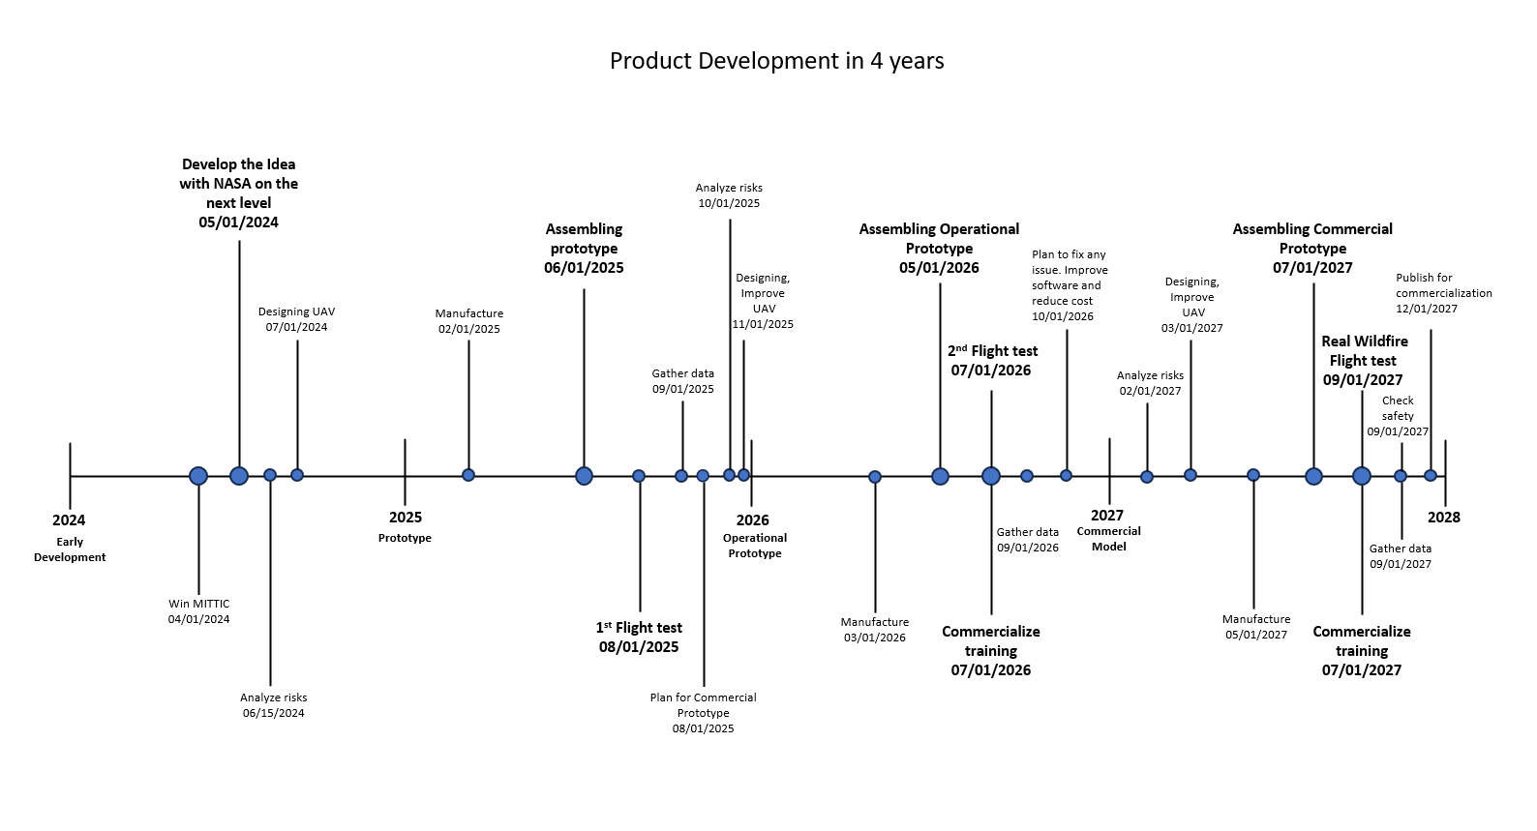

1. **Product Development Timeline**

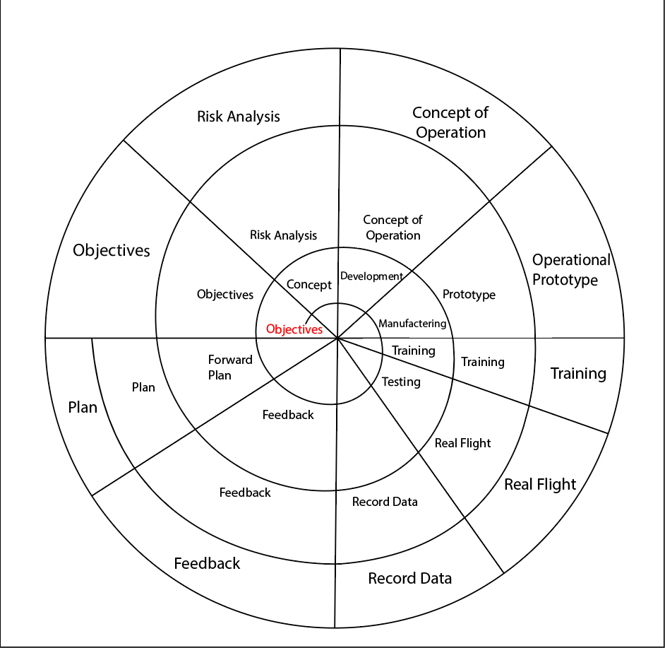

**2. Spiral Model**

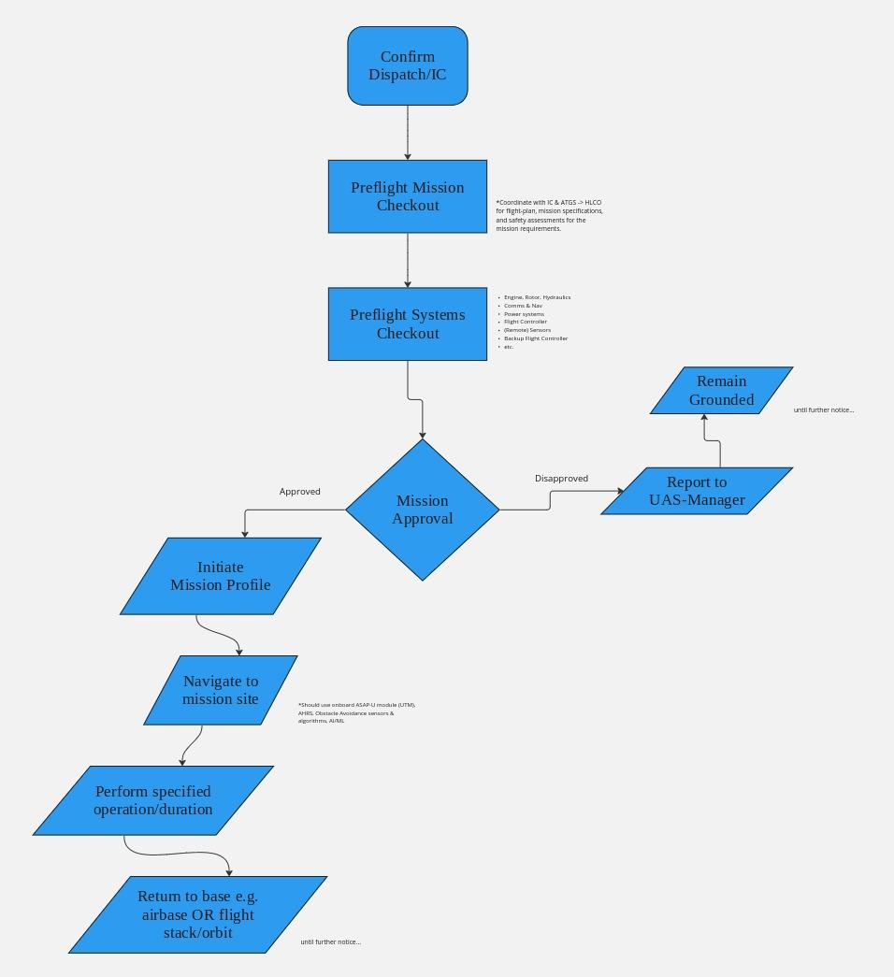

**3. UAS Concept of Operations**

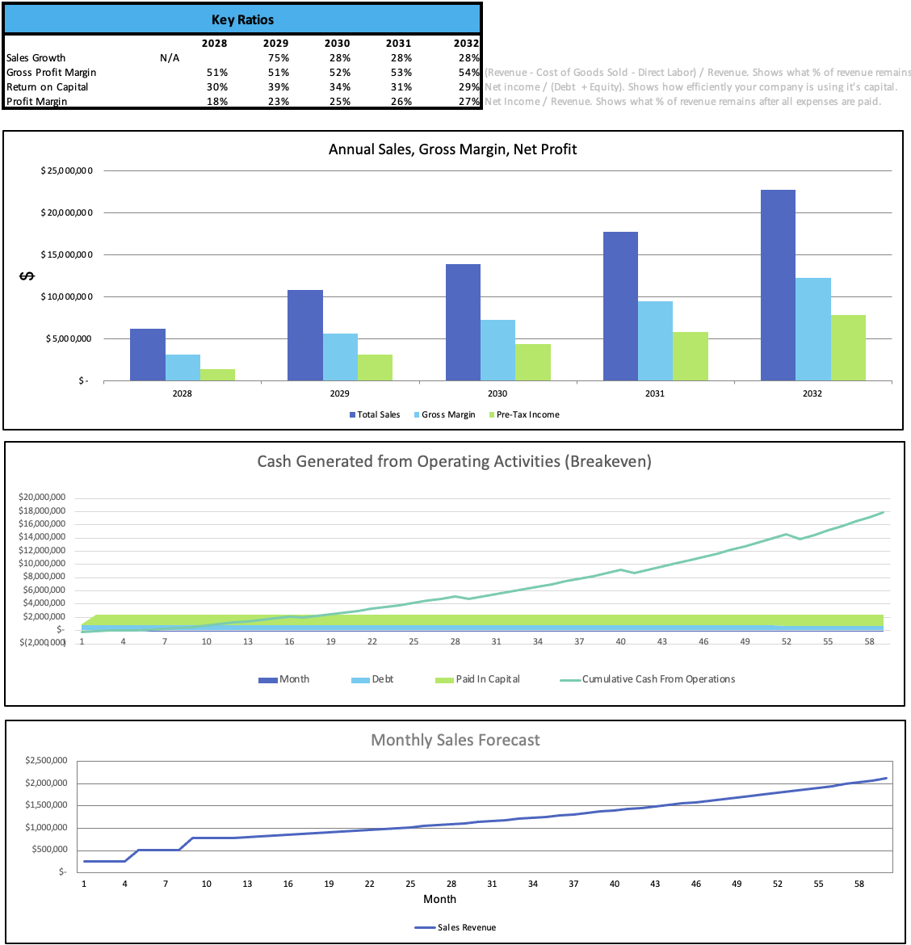

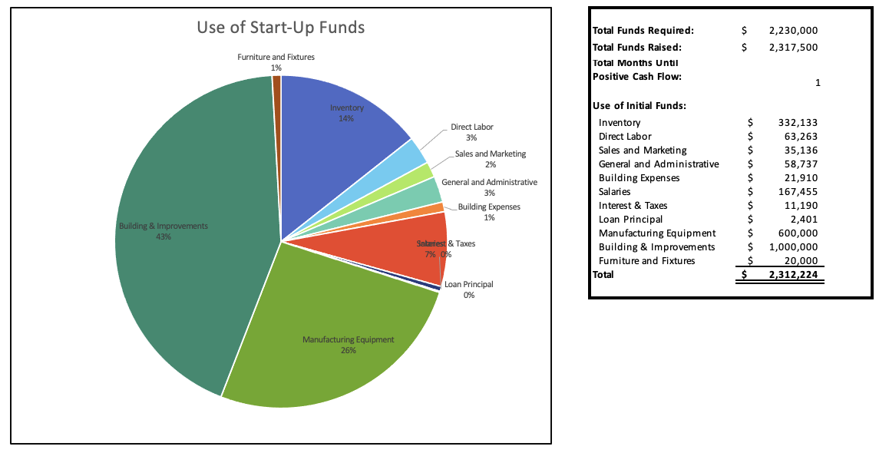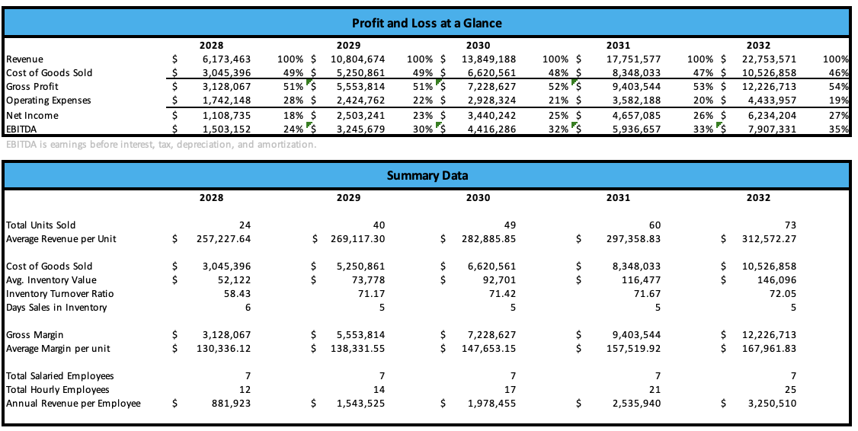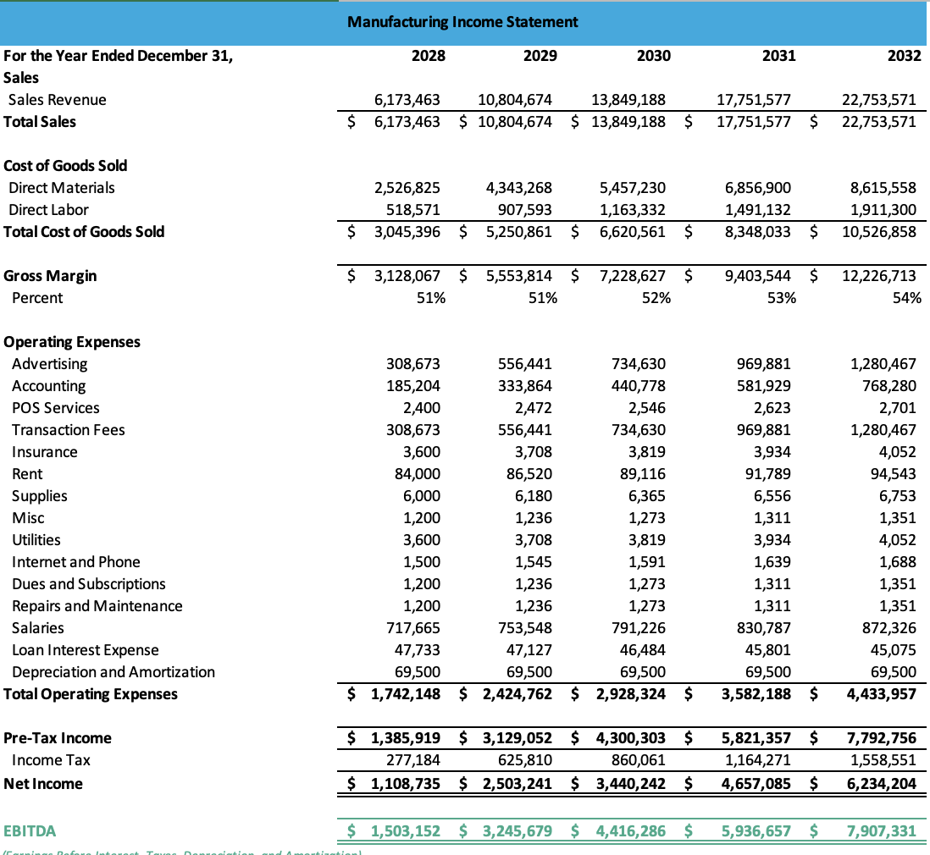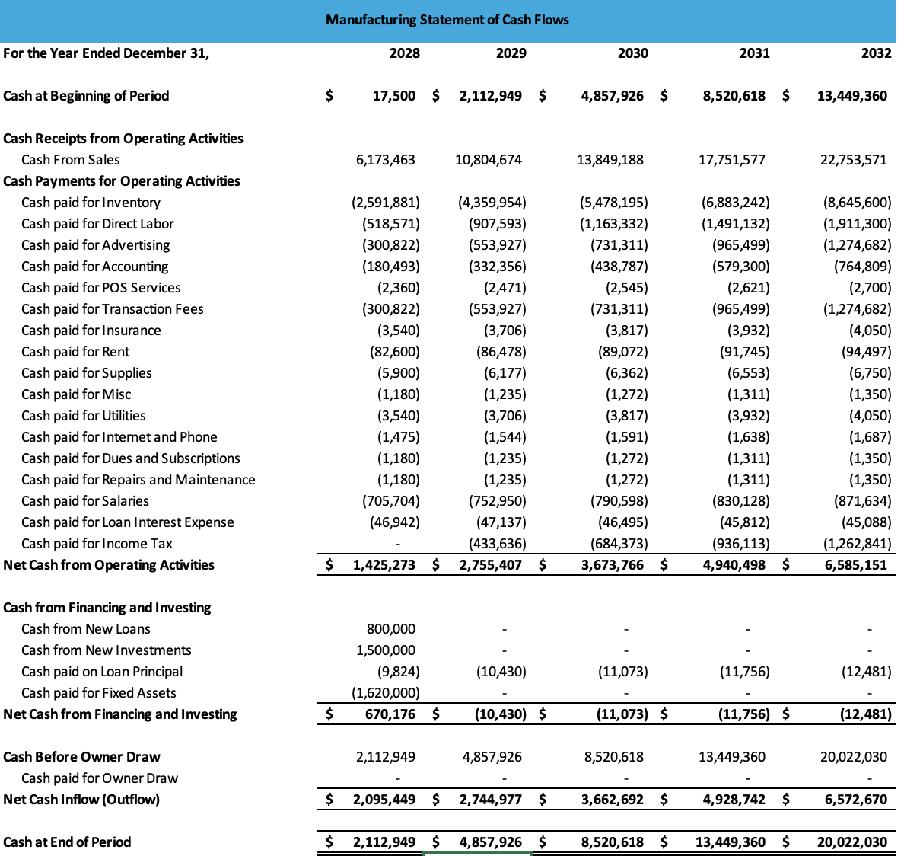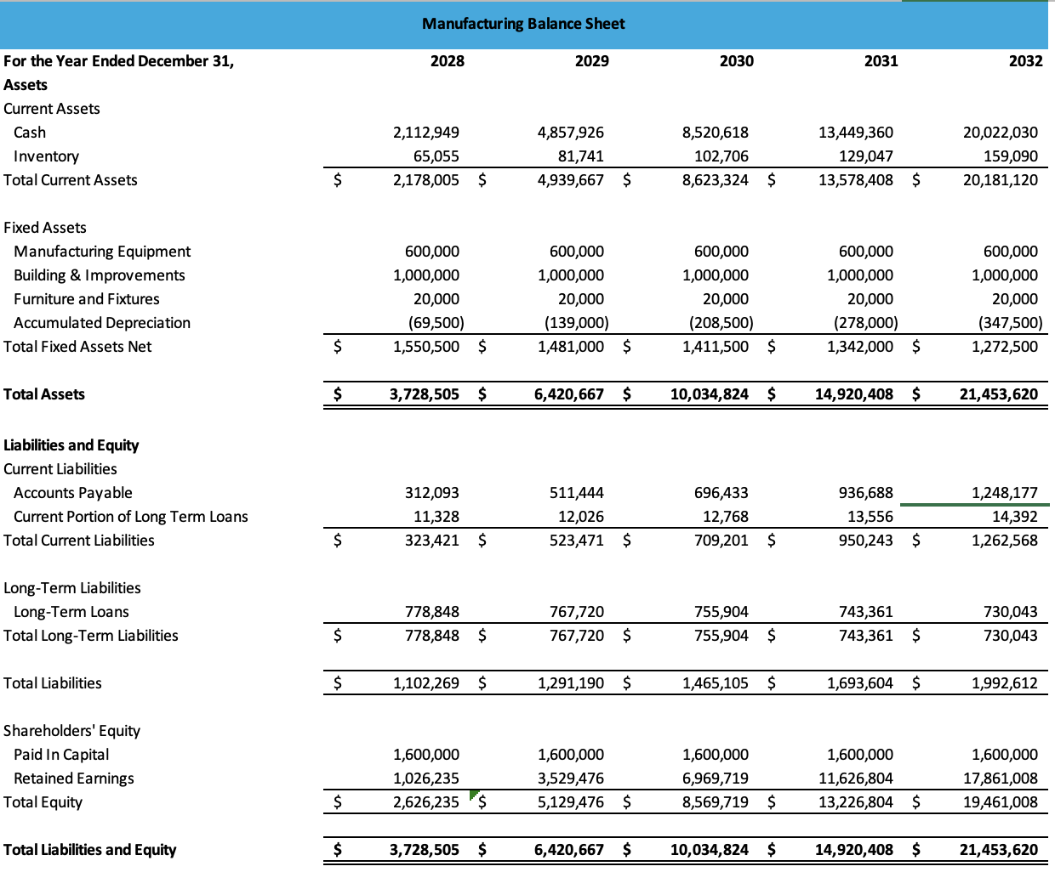

**Outreach**

We intend to collaborate with The E & I Club, an HCC group, for our first event in order to highlight our incredible time at NASA. In the upcoming months, we will host an event where we will invite local industry mentors to speak with and network with the students in attendance. We are going to work with a community event for our second outreach event. Every year, students and the surrounding community are welcome to attend the festival held by Innovation Spark, a non-profit organization with headquarters in Houston. We want to ask for a table at the event to introduce the community to MITTIC and its influence on our team, with NASA's help.

**Use of Funds**

In the event that our team places in the MITTIC Space Tank competition, we have carefully planned how we will utilize the funds to further our project and achieve our goals. This section provides a detailed breakdown of how we intend to use the funds.

We intend to put most of our funding back into improving and validating our concept. We will allocate 50% of the awarded funds to building and testing our prototype. This includes the costs of materials and manufacturing, as well as hiring skilled engineers and technicians, if needed, to refine and enhance our innovation. 15% of our funding will go towards filing for a patent for our breakthrough suppression drone design.

We understand the importance of sound business strategy; therefore, we will allocate a portion of the funds to hiring experienced consultants who can guide us in expanding our business. We will need recommendations from experts in areas such as market analysis, business development, and financial planning. We will allocate about 20% of Finally, the remaining 15% of funds will go towards our team PI for his assistance in this competition.

References

Astute Analytics. (2023, September 19). Global Forest Wildfire Detection System Market. Forest Wildfire Detection System Market. https://www.astuteanalytica.com/industry-report/forest-wildfire-detection-system-market

Business Research Insiders. (2024, February 26). Aerial firefighting market size, share, growth, and industry analysis by type (multi-rotor, fixed wing, helicopter) by application (firefighting organizations, military & others) and regional insights and forecast to 2031. Aerial Firefighting Market Size, Growth, Forecast Analysis, 2031. https://www.businessresearchinsights.com/market-reports/aerial-firefighting-market-109387

Cherney, M. (2024, January 20). Firefighters used to bet on wildfires easing at night. not anymore. The Wall Street Journal. https://www.wsj.com/world/firefightersused-to-bet-on-wildfires-easing-at-night-not-anymore-7f7d6204

Commercial drone market size, Share & Trends Report 2030. Commercial Drone Market Size, Share & Trends Report 2030. (2024). https://www.grandviewresearch.com/industry-analysis/global-commercial-drones-market#:~:text=b.-,The%20global%20commercial%20drone%20market%20size%20was%20estimated%20at%20USD,USD%2022.98%20billion%20in%202023.

Kopardekar, P., & Grindle, L. (2021, May 13). NASA ARMD Wildfire Management Workshop. https://www.nasa.gov/wp-content/uploads/2021/09/nasa_armd_wildfire_management_workshop_6.1.2021_v13.pdf

Laricchia, F. (2023, November 7). Global drone market size 2030. Statista. https://www.statista.com/statistics/1234521/worldwide-drone-market/

Miller, G. (2019, October 29). Kaman receives order for K-Max Helicopter. Kaman Corporation. https://kaman.com/kaman-receives-order-for-k-max-helicopter/

**Letter of Support  
